# **Selecting a Linux Distribution and Types of Installation**

Now that we know what Linux is, it is time that to learn how we should install it on the computer and choose which Distribution we should use. Let us start by understanding what a Linux Distribution is.

## **What is a Linux Distribution?**

Well, now as you know that **Linux is an open-source, free to use kernel** .It is used by programmers, organizations, profit and non-profit companies around the world in order to **create Operating systems to suit their individual requirements**.

To prevent hacking attempts, many organizations keep their Linux operating systems private.

Many others, make their variations of Linux available publicly so the whole world can benefit at large.

These versions/ types /kinds of **Linux operating system are called Distributions**.

**How many distributions are out there?**

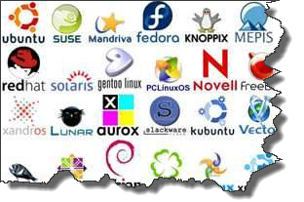

There are **hundreds of Linux operating systems or Distributions** available these days. Many of them are designed with a specific purpose in mind. For example, to run a **web server or to run on network switches like routers, modems** etc.

The latest example of one of the most popular smartphone based **Linux Distribution is Android!**

Many of these Distributions are built to offer**excellent personal computing**.

Here, are a few popular Linux Distributions (also called Linux Distro) -

|  |  |  |
| --- | --- | --- |
| **Linux Distribution** | **Name** | **Description** |
| Selecting a Linux Distribution and Types of Installation | **Arch** | This Linux Distro is popular amongst Developers. It is an independently developed system .It is designed for users who go for a do-it-yourself approach. |
| Selecting a Linux Distribution and Types of Installation | **CentOS** | It is one of the most used Linux Distribution for enterprise and web servers. It is a free enterprise class Operating system and is based heavily on Red Hat enterprise Distro. |
| Selecting a Linux Distribution and Types of Installation | **Debian** | Debian is a stable and popular non-commercial Linux distribution. It is widely used as a desktop Linux Distro and is user-oriented. It strictly acts within the Linux protocols. |
| Selecting a Linux Distribution and Types of Installation | **Fedora** | Another Linux kernel based Distro, Fedora is supported by the Fedora project, an endeavor by Red Hat. It is popular among desktop users. Its versions are known for their short life cycle. |
| Selecting a Linux Distribution and Types of Installation | **Gentoo** | It is a source based Distribution which means that you need to configure the code on your system before you can install it. It is not for Linux beginners, but it is sure fun for experienced users. |
| Selecting a Linux Distribution and Types of Installation | **LinuxMint** | It is one of the most popular Desktop Distributions available out there. It launched in 2006 and is now considered to be the fourth most used Operating system in the computing world. |
| Selecting a Linux Distribution and Types of Installation | **OpenSUSE** | It is an easy to use and a good alternative to MS windows. It can be easily set up and can also run on small computers with obsolete configurations. |
| Selecting a Linux Distribution and Types of Installation | **RedHat enterprise** | Another popular enterprise based Linux Distribution is Red Hat Enterprise.It has evolved from Red Hat Linux which was discontinued in 2004. It is a commercial Distro and very popular among its clientele. |
| Selecting a Linux Distribution and Types of Installation | **Slackware** | Slackware is one of the oldest Linux kernel based OS's. It is another easy desktop Distribution. It aims at being a 'Unix like' OS with minimal changes to its kernel. |
| Selecting a Linux Distribution and Types of Installation | **Ubuntu** | This is the third most popular desktop operating system after Microsoft Windows and Apple Mac OS. It is based on the Debian Linux Distribution and it is known for its desktop environment. |

## **The Best Linux Distribution !**

The term best is **relative. Each Linux distribution is built for a specific purpose built to meet the demands of its target users.**

The desktop Distributions are **available for free** at their respective websites. You might want to try them one by one till you get to know which Distribution you like the most. Each one of them offers it's own unique design, **applications** and **security**.

We will be using Ubuntu for our learning purpose as it's easy for a beginner to understand.

## **Installing Linux**

Let's look the various methods we can use to install Ubuntu.

## **USB stick**

This is one of the easiest methods of installing Ubuntu or any distribution on your computer. Follow the steps.

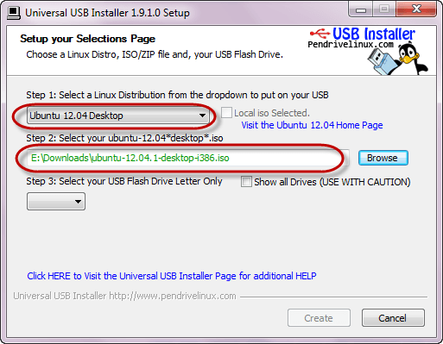

* Download the .iso or the OS files on your computer from this [link](http://www.ubuntu.com/download/desktop) .
* Download free software like '[Universal USB installer](http://www.pendrivelinux.com/universal-usb-installer-easy-as-1-2-3/)'to make a bootable USB stick.
* Boot your computer through it and follow the instructions as they come.

## **Live CD**

Those who like the way a CD runs should try using this method.

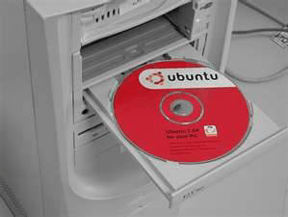

([image source](http://www.facilware.com/correr-ubuntu-live-cd-como-usuario-root.html))

* Download the .iso or the OS files onto your computer from this link <http://www.ubuntu.com/download/desktop>.
* Burn the files on a CD .
* Boot your computer through the optical drive and follow the instructions as they come.

## **Virtual Installation**

This is a popular method to install a Linux operating system. Virtual installation offers you the freedom of running Linux on an existing OS already installed on your computer. This means if you have Windows running, then you can just run Linux with a click of a button.

Virtual machine software like Oracle VM can install Ubuntu in easy steps. Let us look at them.

* Download and install [Oracle VM](http://www.oracle.com/technetwork/server-storage/virtualbox/downloads/index.html#vbox) on your computer.
* Click on new on the VM tool bar. Enter the VN Name and OS Type.
* Follow the instructions. You will see Ubuntu configured in your VM.

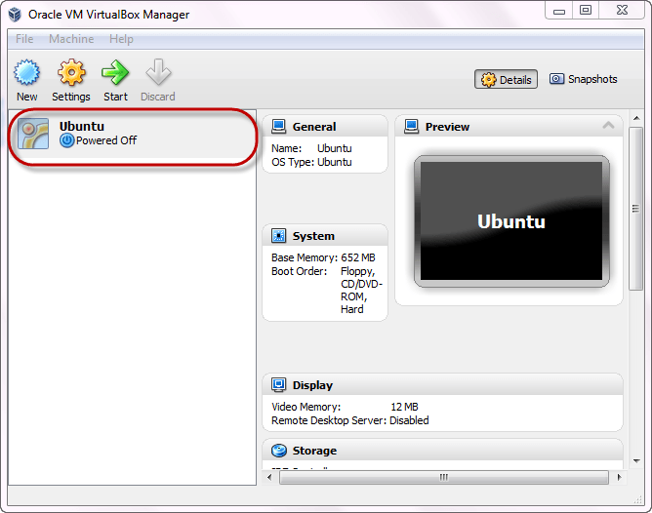

Double click on it . Ubuntu will load as a separate machine while you are working on Windows

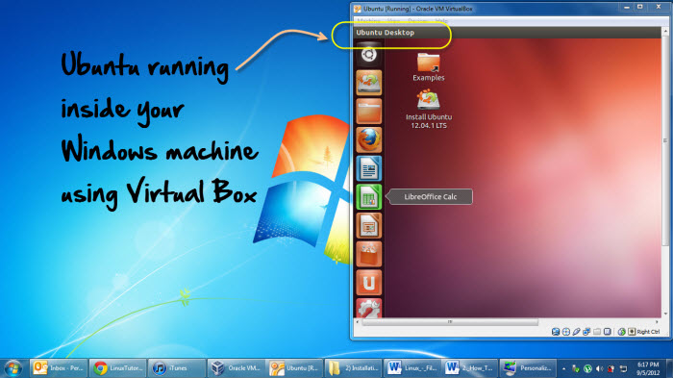

### **Testing a Distribution**

Those who want to test a distribution before installing it on a computer and replacing the existing OS would be surprised to know that you can easily run it from the USB stick/CD . Then you can easily check out the interface. This way you can learn whether you like the distribution or not and can either install or move on to another one.

You can even install Linux side by side with Windows or any other OS (dual booting). So you can also go for a system which has two of your favorite operating systems installed on it.

**Summary**

* An operating system based on the Linux kernel is called a Distribution or Distro
* There are hundreds of Distributions available, some of which are designed to accomplish a sole purpose like running servers, act as network switches etc.
* Naming the best Linux Distribution is difficult as they are made for different.
* Linux can be installed in your system via the below mentioned methods:
* USB stick
* Live CD
* Virtual Installation